 |  | 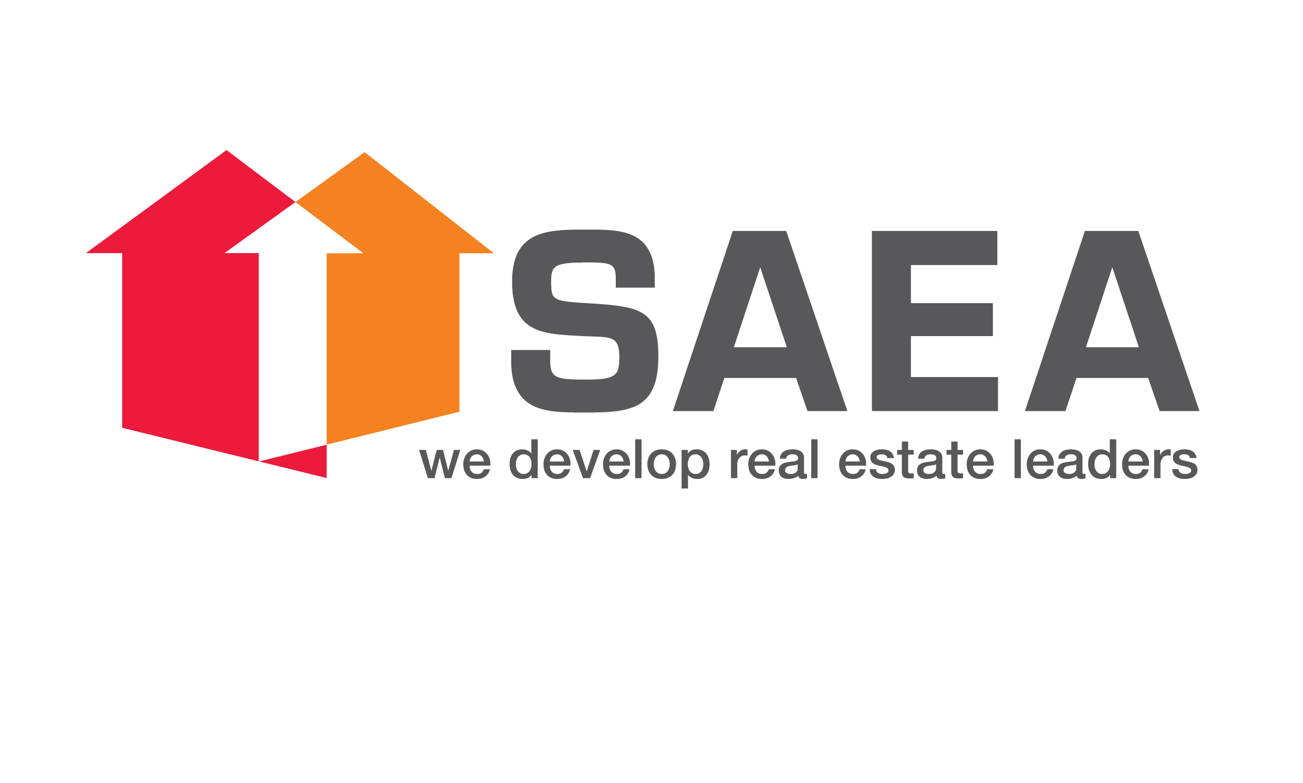

ASIA PACIFIC REAL ESTATE CONGRESS (3-5 SEPTEMBER 2013)
Sponsorship Package
Please tick | Amount | Entitlements
□ | S$ 10,000 | - Named as PLATINUM Sponsor  - Souvenir Magazine (Back cover or Centrespread)  - Logo* on stage banner/backdrop and newspaper advertisement**  - Booth space & two Congress Passes
□ | S$ 5,000 | - Named as GOLD Sponsor  - Souvenir Magazine (IFC/IBC/Centre left/Centre right)  - Logo* on stage banner/ backdrop and newspaper advertisement**  - Booth space & two Congress Passes
□ | S$ 3,000 | - Named as SILVER Sponsor  - Souvenir Magazine ( ½ page)  - Logo* on stage banner/backdrop and newspaper advertisement**  - Booth space & two Congress Passes
□ | S$ 1,500 | - Named as BRONZE Sponsor  - Logo* on stage banner/ backdrop  - Two Congress Passes
□ | S$ 1,500 | - Booth space & two Congress Passes
* Logo size and position on stage backdrop and/or advertisement will differ depending on the sponsored amount.
Sponsor to provide colour separation film for advertisement and logo in high resolution for stage backdrop
** See Annex A (sample of a newspaper advertisement for Congress 2012) on page 2 for reference

Ad Space in Souvenir Magazine
Please tick | Amount | Entitlements
□ | S$ 1,800 | - Souvenir Magazine (full page)
□ | S$ 1,000 | - Souvenir Magazine (½ page)
□ | S$ 600 | - Souvenir Magazine ( ¼ page)

< THANK YOU FOR YOUR SPONSORSHIP >
Please return completed form together with cheque payment to:
FIABCI Singapore, 110 Middle Road #09-00, Chiat Hong Building, Singapore 188968
Cheque to be made payable to “ FIABCI Singapore ”

Company ………………………………………………………………………………………………………………………......………....…
Address …………………………………………………………………………………….… Postal code ……………..…..........….…

Contact Person…………………………………………………….……..….….. | …………………..……………...……..  Authorised Signature &  Company stamp
Tel ………..…………………………………………………………………..….…... | …………………..……………...……..  Authorised Signature &  Company stamp
Email …………………………………………..…………………………………….. | …………………..……………...……..  Authorised Signature &  Company stamp

Annex A

Sample of a newspaper advertisement for National Real Estate Congress 2012:

